Practical File
Natural Language Processing



Session – 2022-2026

Submitted by:
Devansh Kumar
B.tech CSE- 7th sem
A25305222054

Index

S. No. | Practical Name | Page No.
1. | Perform word and sentence tokenization using NLTK | 3
2. | Stop Words Removal | 4
3. | Perform Stemming using NLTK | 5
4. | Perform Lemmatization using NLTK | 6
5. | Chunking with NLTK | 7
6. | Perform NER using NLTK | 8
7. | Perform PoS using NLTK | 9
8. | Perform TF-IDF Calculation for a given corpus | 10
9. | CYK Parsing | 11
10. | N-Grams | 13
11. | Perform Probability Calculation from Corpus | 14
12. | Perform NER using Stanford NER | 16

- Aim - Tokenization – Word & Sentence
Theory –
Tokenization is the process of dividing text into meaningful units called tokens. In NLP, this typically involves breaking a paragraph into sentences (sentence tokenization) and then splitting those sentences into words (word tokenization). It’s a crucial preprocessing step that helps machines understand and analyse text more effectively.

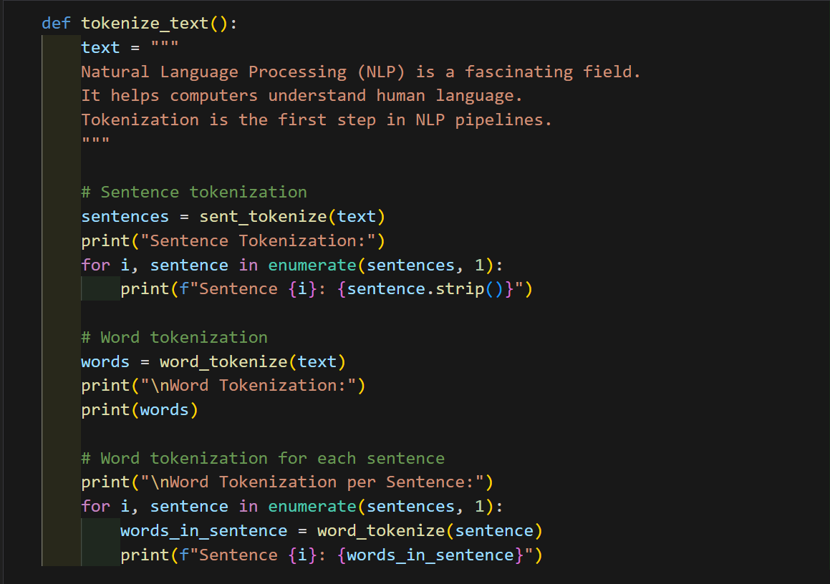

Output –

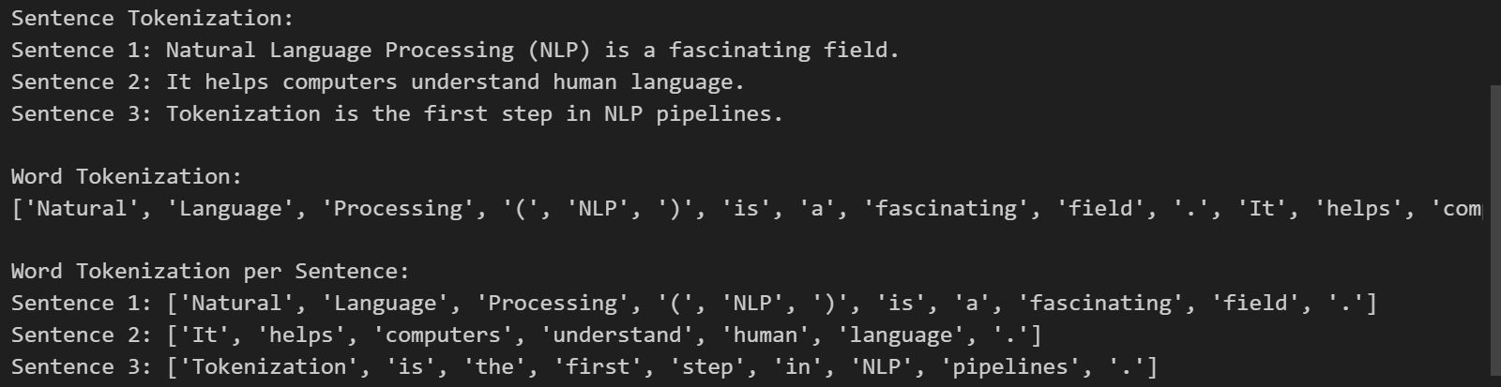

- Aim - Stop Words Removal
Theory –
Stop Words Removal is a text preprocessing technique in NLP where commonly used words like "is", "the", "and", "in" are removed from the text. These words usually carry little semantic meaning and are filtered out to focus on the more informative words, improving the efficiency and accuracy of tasks like text classification, sentiment analysis, and search.
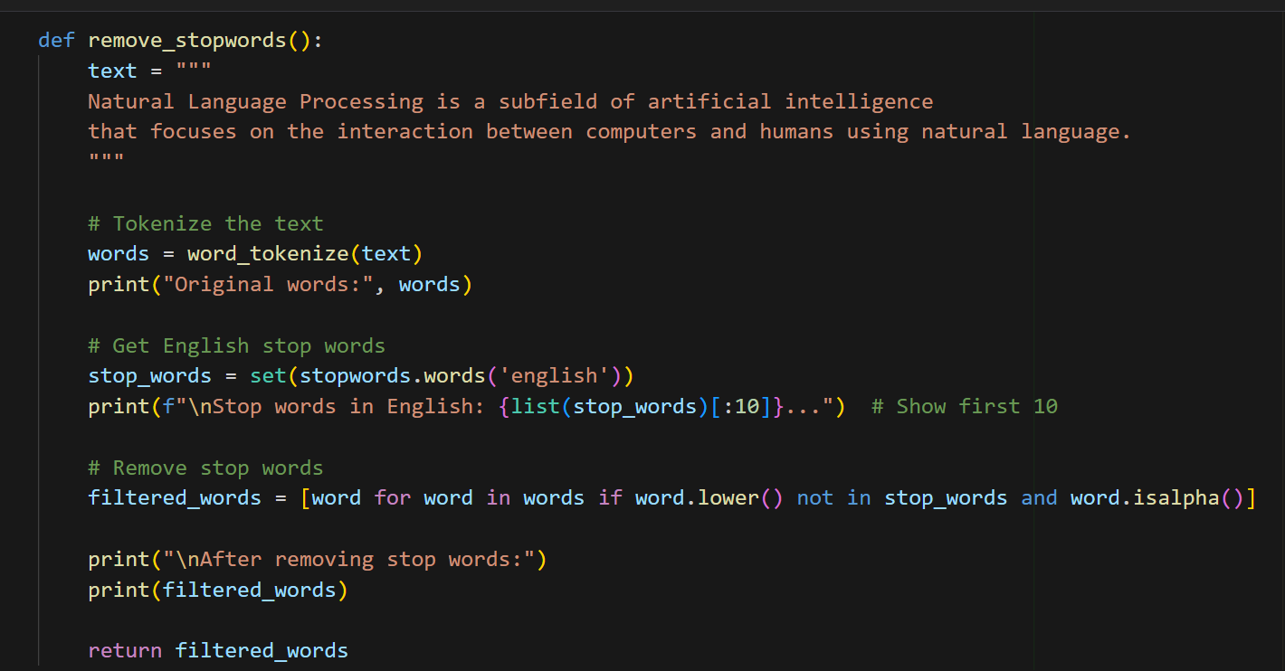

Output –

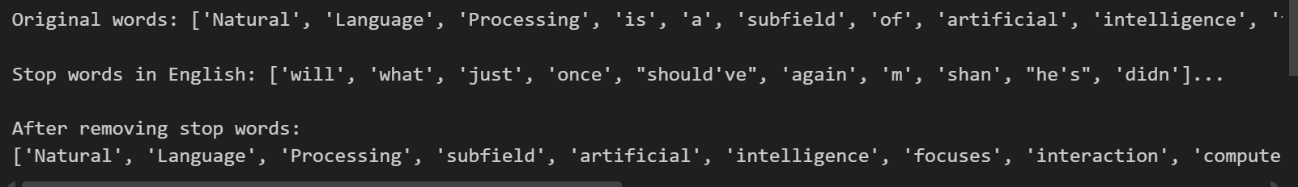

- Aim – Perform Stemming
Theory –
Stemming is a text normalization technique in NLP that reduces words to their root or base form by removing suffixes. For example, "playing", "played", and "plays" are all reduced to "play". This helps in treating related words as the same during tasks like search, classification, and indexing, improving consistency and reducing dimensionality.
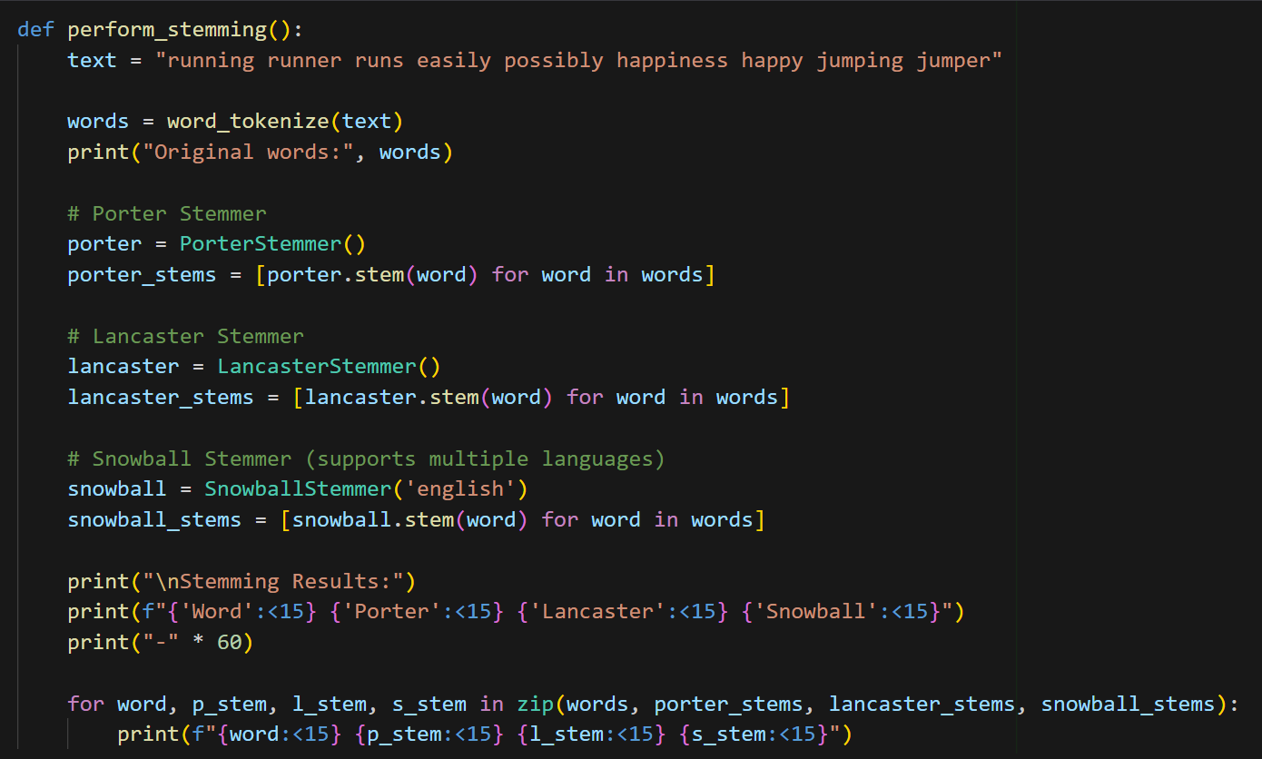

Output –

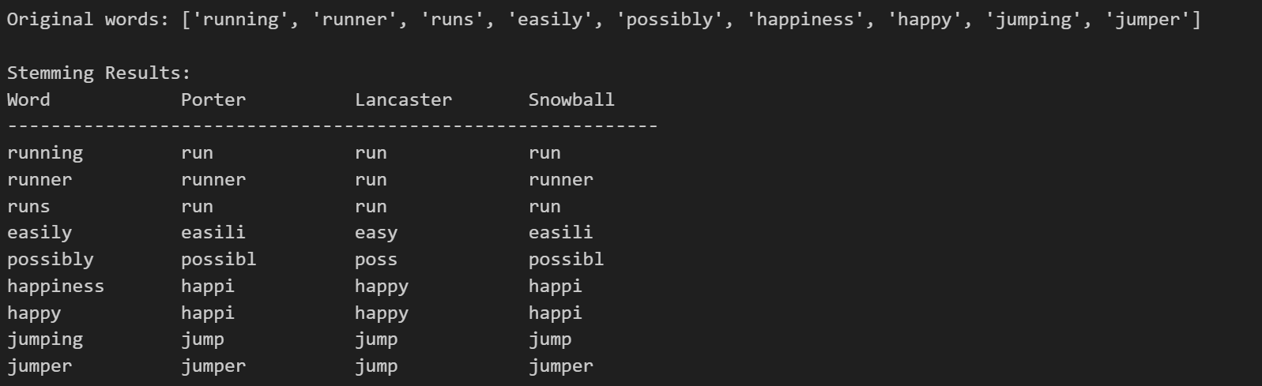

- Aim – Lemmatization
Theory –
Lemmatization is a text preprocessing technique in NLP that reduces words to their base or dictionary form, known as the lemma. Unlike stemming, it considers the context and part of speech to ensure the root word is meaningful. For example, "running" becomes "run", and "better" becomes "good". This helps improve the accuracy of text analysis and model performance.
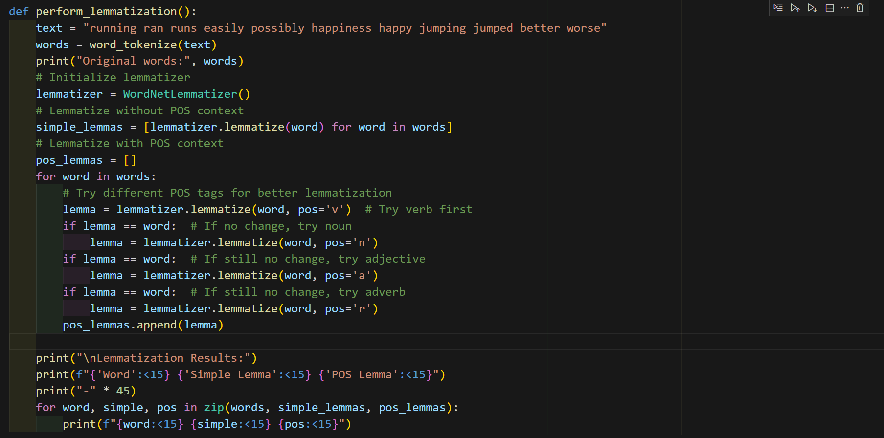
Output –
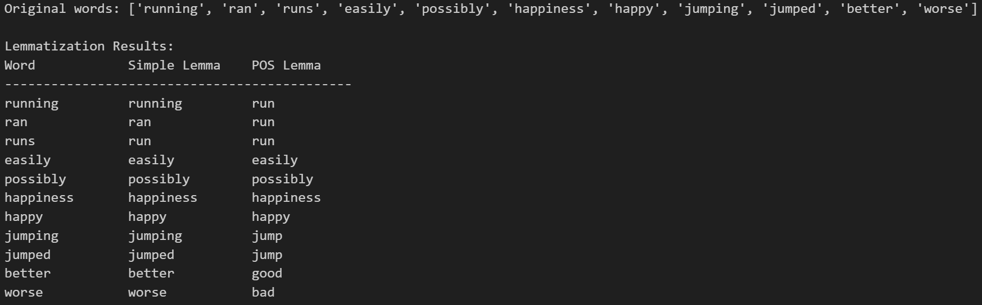

- Aim - Chunking with NLTK
Theory –
Chunking in NLP is the process of extracting meaningful phrases from a sentence by grouping words into syntactic units like noun or verb phrases. Using NLTK, chunking is typically done after POS tagging, where patterns (like noun followed by adjectives) are defined using regular expressions to identify and extract these chunks. It helps in understanding sentence structure and is useful in tasks like information extraction and question answering.
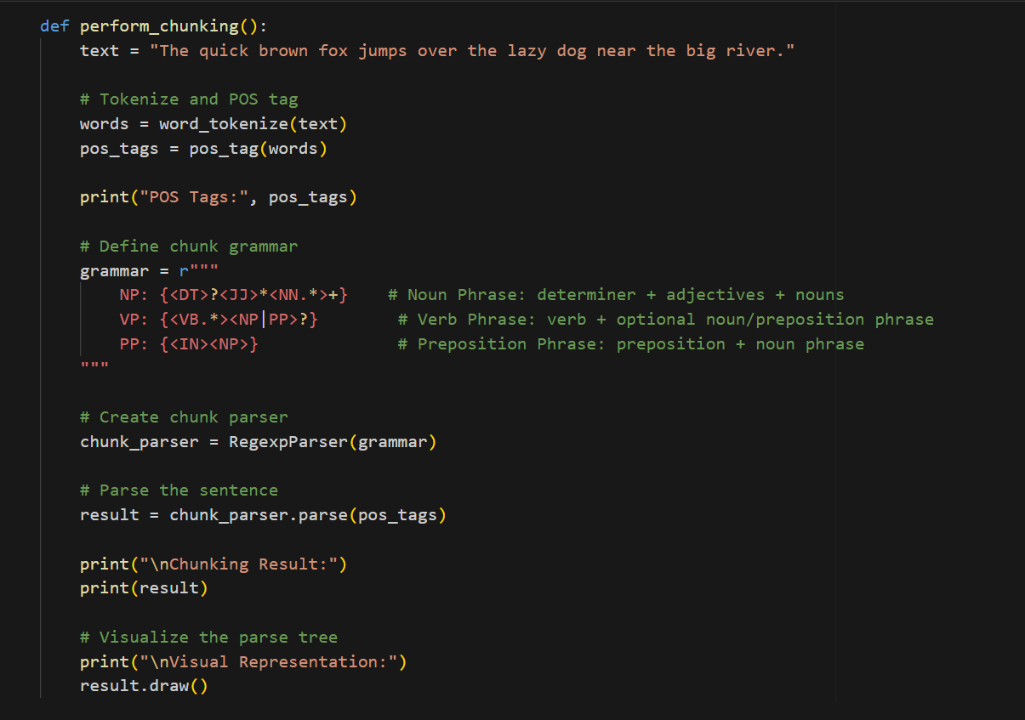

Output –

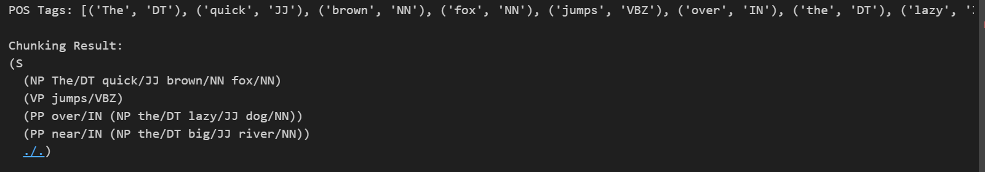

- Aim – NER (Name Entity Recognition)
NER is an NLP technique used to identify and classify key elements in text into predefined categories such as names of people, organizations, locations, dates, and more. It helps in extracting structured information from unstructured text, making it useful for applications like information retrieval, question answering, and content categorization.
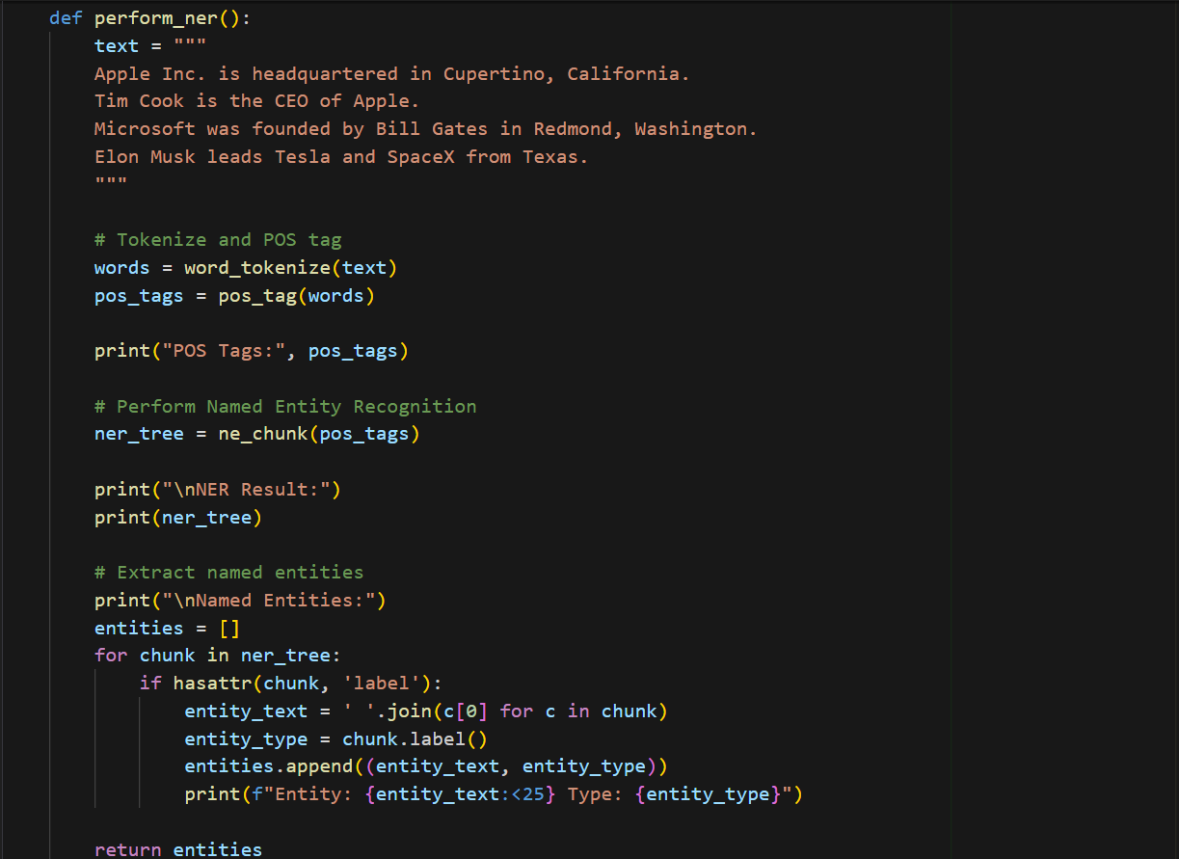
Output –
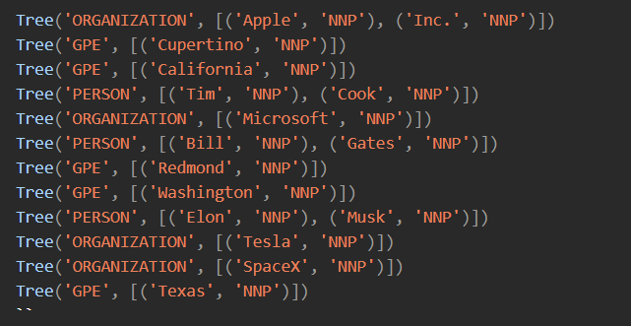
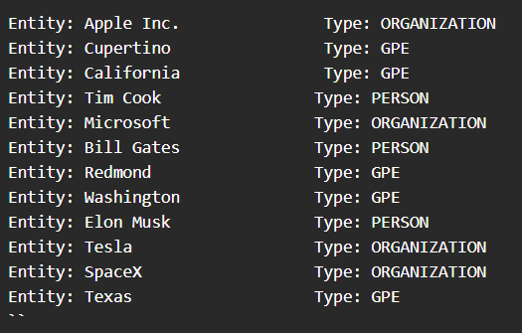
- Aim – Perform Part-of-Speech (PoS) Tagging
Theory –
PoS is the process of labeling each word in a sentence with its grammatical category, such as noun, verb, adjective, etc. It helps in understanding the syntactic structure of text and is essential for tasks like parsing, information extraction, and machine translation. Tools like NLTK and spaCy use linguistic rules and statistical models to perform PoS tagging accurately.
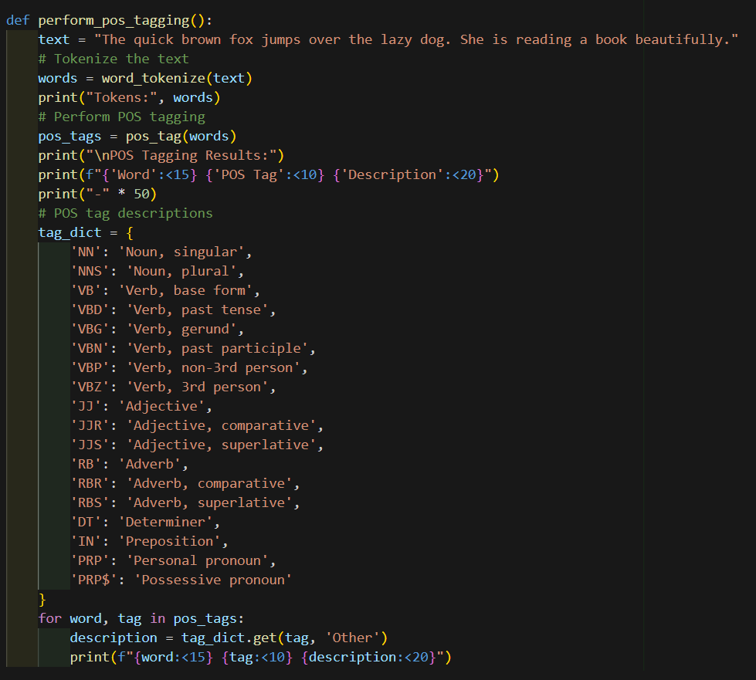

Output –
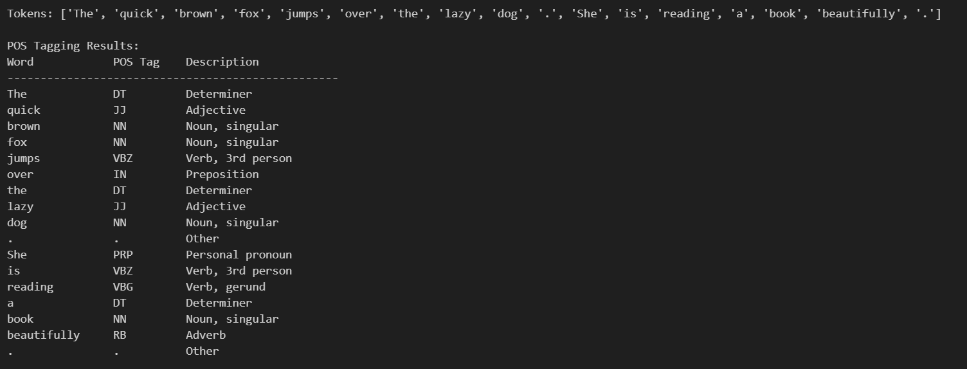
- Aim - TF-IDF Calculation
Theory –
TF-IDF (Term Frequency–Inverse Document Frequency) is a statistical measure used in NLP to evaluate how important a word is to a document in a collection or corpus. It combines two metrics: Term Frequency (TF), which counts how often a word appears in a document, and Inverse Document Frequency (IDF), which reduces the weight of common words across documents. TF-IDF helps in identifying keywords and improving the relevance of search results and text classification.
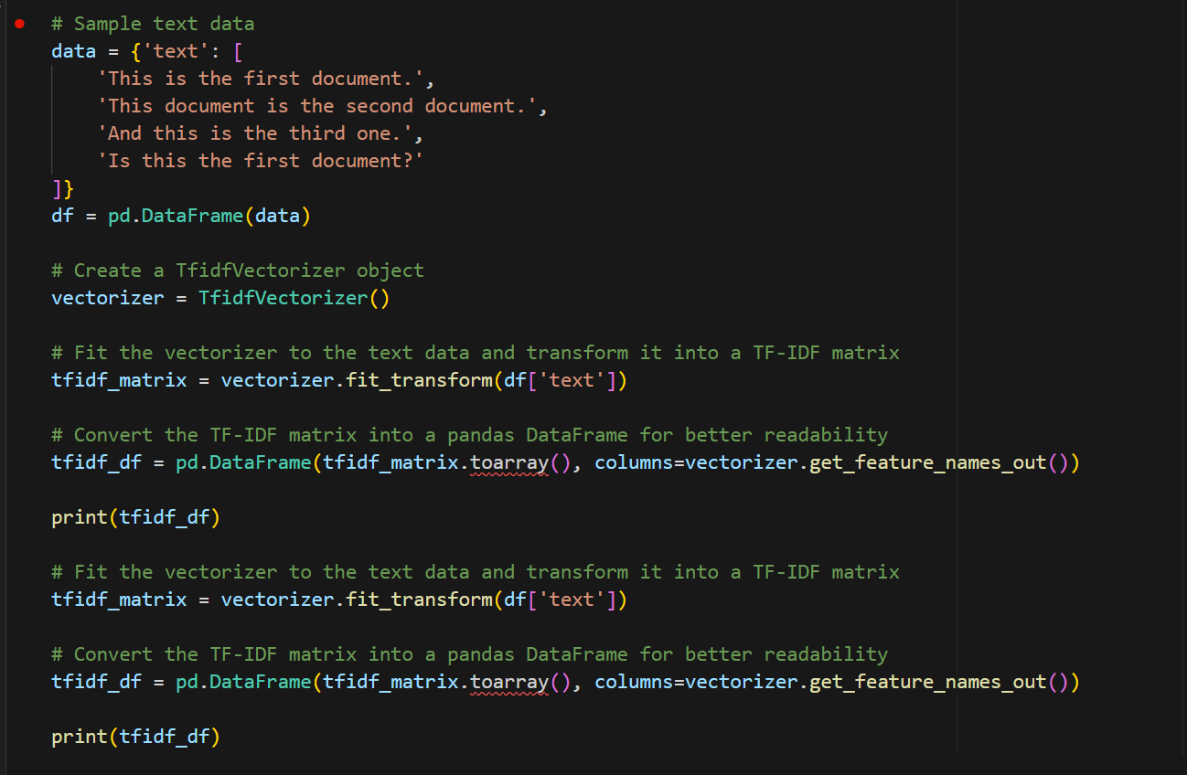

Output –

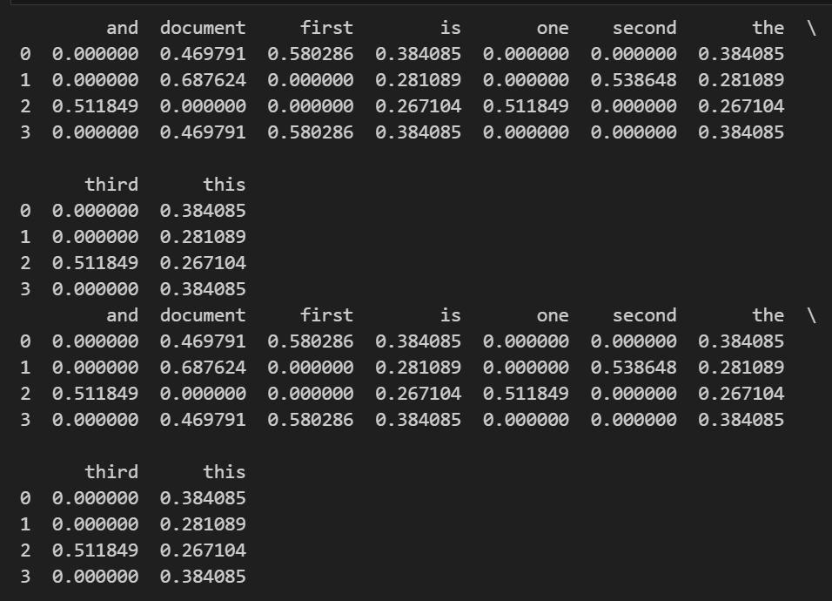
- CYK Parsing –
CYK Parsing (Cocke–Younger–Kasami) is a bottom-up parsing algorithm used for context-free grammars in Chomsky Normal Form (CNF). It checks whether a given string can be generated by a grammar and builds a parse table to represent possible derivations. CYK is widely used in computational linguistics for syntax analysis and is known for its efficiency in parsing ambiguous grammars.

class CYKParser:
def __init__(self, grammar):
self.grammar = grammar

def parse(self, sentence):
words = sentence.split()
n = len(words)
# Initialize the table
table = [[set() for _ in range(n)] for _ in range(n)]

# Fill the diagonal (terminal rules)
for i in range(n):
for lhs, rhs_list in self.grammar.items():
for rhs in rhs_list:
if len(rhs) == 1 and rhs[0] == words[i]:
table[i][i].add(lhs)

# Fill the rest of the table
for length in range(2, n + 1): # length of span
for i in range(n - length + 1):
j = i + length - 1
for k in range(i, j): # split position
for lhs, rhs_list in self.grammar.items():
for rhs in rhs_list:
if len(rhs) == 2:
B, C = rhs
if B in table[i][k] and C in table[k + 1][j]:
table[i][j].add(lhs)

return table, 'S' in table[0][n - 1]

def perform_cyk_parsing():
# Define a simple CFG in Chomsky Normal Form
grammar = {
'S': [['NP', 'VP']],
'NP': [['Det', 'N'], ['NP', 'PP']],
'VP': [['V', 'NP'], ['VP', 'PP']],
'PP': [['P', 'NP']],
'Det': ['the', 'a'],
'N': ['cat', 'dog', 'mat', 'house'],
'V': ['sat', 'chased', 'slept'],
'P': ['on', 'in', 'with']
}

# Test sentences
test_sentences = [
"the cat sat",
"the cat sat on the mat",
"the dog chased the cat",
"the cat slept in the house"
]

parser = CYKParser(grammar)

for sentence in test_sentences:
table, is_valid = parser.parse(sentence)
words = sentence.split()
n = len(words)

print(f"\nSentence: '{sentence}'")
print(f"Valid: {is_valid}")

if is_valid:
print("Parse table:")
for i in range(n):
for j in range(i, n):
if table[i][j]:
print(f"table[{i}][{j}]: {table[i][j]}")
print("-" * 50)

if __name__ == "__main__":
perform_cyk_parsing()

Output –

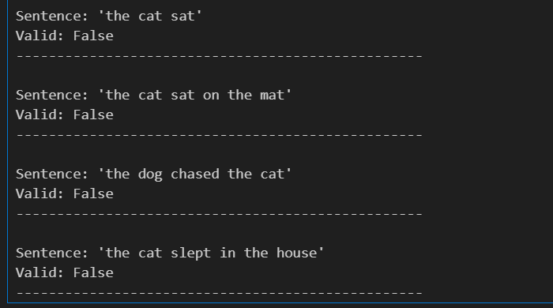
- Aim - N-Grams
Theory –
N-Grams are continuous sequences of n items (usually words or characters) from a given text. They are used in NLP to capture context and patterns in language. For example, in the sentence “I love NLP”, the bigrams (2-grams) are “I love” and “love NLP”.
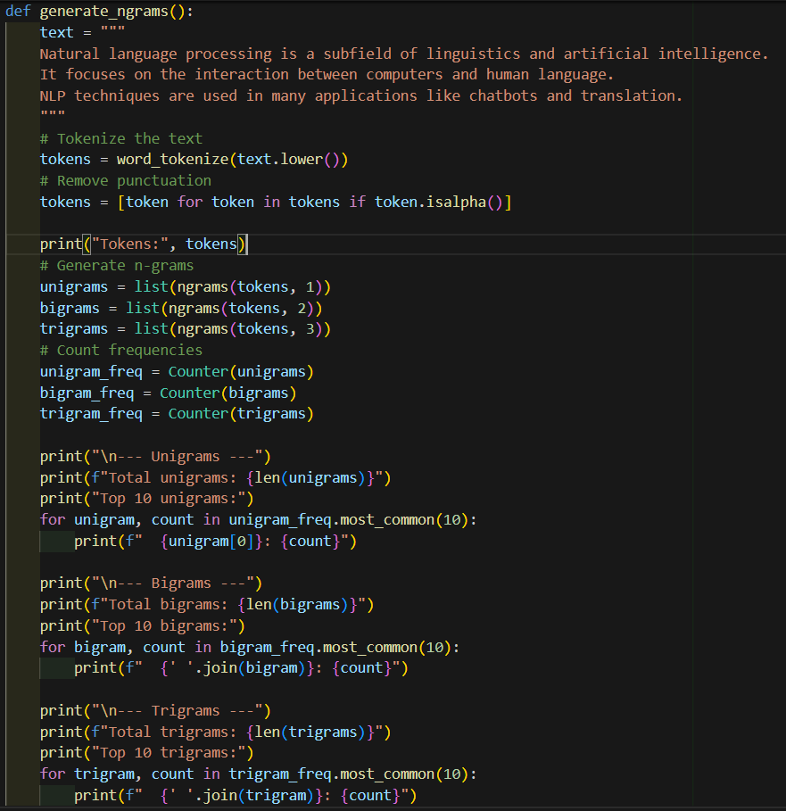
Output –
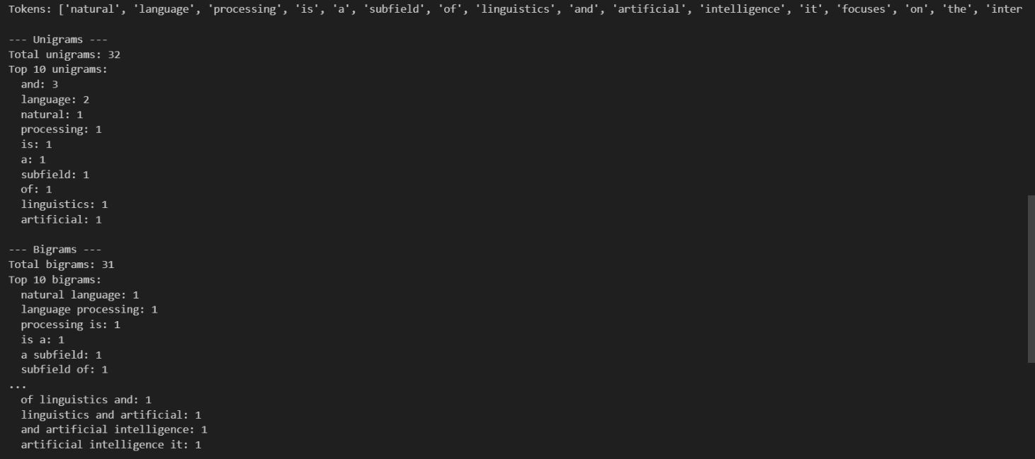

- Aim – Perform Probability Calculation from Corpus
Calculation –
Probability Calculation from Corpus involves estimating the likelihood of a sentence based on how frequently its words or word sequences (n-grams) appear in a given text corpus. This is done using language models like unigram, bigram, or trigram models. The process helps in understanding how natural or likely a sentence is, and is useful in applications like speech recognition, machine translation, and text generation. Smoothing techniques like add-one smoothing are used to handle unseen words or n-grams.
class LanguageModel:
def __init__(self, n=2):
self.n = n
self.ngram_counts = defaultdict(Counter)
self.vocab = set()

def train(self, corpus):
# Tokenize corpus
tokens = []
for text in corpus:
tokens.extend(word_tokenize(text.lower()))
# Remove punctuation and add sentence boundaries
tokens = [token for token in tokens if token.isalpha()]
self.vocab = set(tokens)
# Generate n-grams
for i in range(1, self.n + 1):
ngs = list(ngrams(tokens, i))
self.ngram_counts[i] = Counter(ngs)
def probability(self, sentence):
tokens = word_tokenize(sentence.lower())
tokens = [token for token in tokens if token.isalpha()]
if len(tokens) < self.n:
return 0.0
prob = 1.0
for i in range(len(tokens) - self.n + 1):
ngram = tuple(tokens[i:i + self.n])
context = tuple(tokens[i:i + self.n - 1])

if self.n == 1:
# Unigram probability
count_ngram = self.ngram_counts[1][ngram]
total_unigrams = sum(self.ngram_counts[1].values())
prob *= (count_ngram + 1) / (total_unigrams + len(self.vocab)) # Add-one smoothing
else:
# N-gram probability with smoothing
count_ngram = self.ngram_counts[self.n][ngram]
count_context = self.ngram_counts[self.n - 1][context]
prob *= (count_ngram + 1) / (count_context + len(self.vocab))
return prob
def perplexity(self, sentence):
prob = self.probability(sentence)
if prob == 0:
return float('inf')
return math.pow(1/prob, 1/len(sentence.split()))
def calculate_probability():
# Sample corpus
corpus = [
"the cat sat on the mat",
"the dog sat on the log",
"cats and dogs are great pets",
"the cat chased the dog",
"dogs are loyal animals",
"the cat sleeps on the sofa"
]
# Create and train language models
unigram_model = LanguageModel(n=1)
bigram_model = LanguageModel(n=2)
trigram_model = LanguageModel(n=3)
unigram_model.train(corpus)
bigram_model.train(corpus)
trigram_model.train(corpus)
# Test sentences
test_sentences = [
"the cat sat",
"the dog chased",
"cats are animals",
"unknown words here"
]
print("Probability Calculation Results:")
print("=" * 60)
for sentence in test_sentences:
print(f"\nSentence: '{sentence}'")
print(f"Unigram Probability: {unigram_model.probability(sentence):.6f}")
print(f"Bigram Probability: {bigram_model.probability(sentence):.6f}")
print(f"Trigram Probability: {trigram_model.probability(sentence):.6f}")
print(f"Bigram Perplexity: {bigram_model.perplexity(sentence):.2f}")
Output –
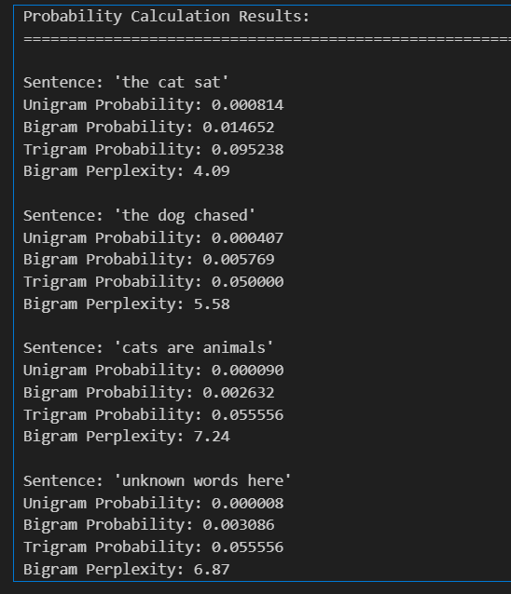

- Aim - NER Using Stanford NER
Theory –
Named Entity Recognition (NER) using Stanford NER involves identifying and classifying named entities in text—such as people, organizations, locations, dates, and more—using the Stanford NLP toolkit. It uses machine learning models trained on annotated corpora to tag entities accurately. Stanford NER is known for its robustness and supports multiple languages and custom training, making it useful for tasks like information extraction, question answering, and content categorization.
def download_stanford_ner():
"""Download Stanford NER if not already present"""
stanford_ner_dir = "stanford-ner"
if not os.path.exists(stanford_ner_dir):
print("Downloading Stanford NER...")
url = "https://nlp.stanford.edu/software/stanford-ner-2020-11-17.zip"
response = requests.get(url, stream=True)

with open("stanford-ner.zip", "wb") as f:
for chunk in response.iter_content(chunk_size=8192):
f.write(chunk)

with zipfile.ZipFile("stanford-ner.zip", "r") as zip_ref:
zip_ref.extractall(".")

os.rename("stanford-ner-2020-11-17", stanford_ner_dir)
os.remove("stanford-ner.zip")
print("Download completed!")

return stanford_ner_dir

def stanford_ner_python(text):
"""Simple Stanford NER implementation using available Python libraries"""
import nltk
from nltk import ne_chunk, pos_tag, word_tokenize
# Download required NLTK data
nltk.download('maxent_ne_chunker')
nltk.download('words')
nltk.download('averaged_perceptron_tagger')
nltk.download('punkt')
# Tokenize and POS tag
tokens = word_tokenize(text)
pos_tags = pos_tag(tokens)
# Perform NER
ner_tree = ne_chunk(pos_tags)
# Extract named entities
entities = []
current_entity = []
current_type = None

for node in ner_tree:
if isinstance(node, nltk.Tree):
if current_entity and node.label() != current_type:
if current_entity:
entities.append((' '.join(current_entity), current_type))
current_entity = []
current_type = node.label()
current_entity.extend([child[0] for child in node])
else:
if current_entity:
entities.append((' '.join(current_entity), current_type))
current_entity = []
current_type = None
if current_entity:
entities.append((' '.join(current_entity), current_type))
return entities
def perform_stanford_ner():
text = """
Apple Inc. was founded by Steve Jobs, Steve Wozniak, and Ronald Wayne in 1976.
The company is headquartered in Cupertino, California.
Tim Cook became CEO in 2011 after Steve Jobs passed away.
Microsoft, led by Satya Nadella, is located in Redmond, Washington.
"""
print("Text:", text)
print("\nStanford-style NER Results:")
print("=" * 50)

entities = stanford_ner_python(text)

for entity, entity_type in entities:
print(f"Entity: {entity:<30} Type: {entity_type}")
Output –
